Yes, however, the standard serial converters are either prewired to connect to Renishaw (JZDP-D005-xxx-E/JZDP-D008-xxx-E) or Heidenhain (JZDP-D003-xxx-E/JZDP-D006-xxx-E).
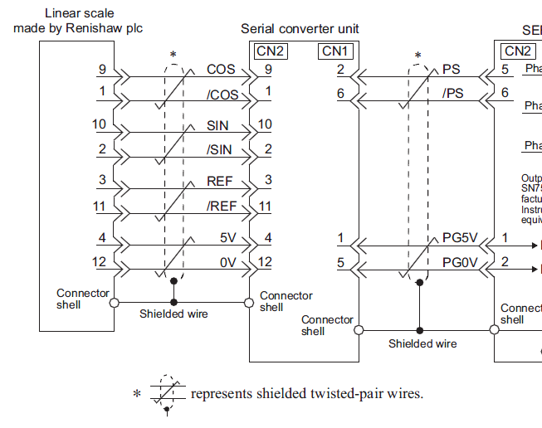
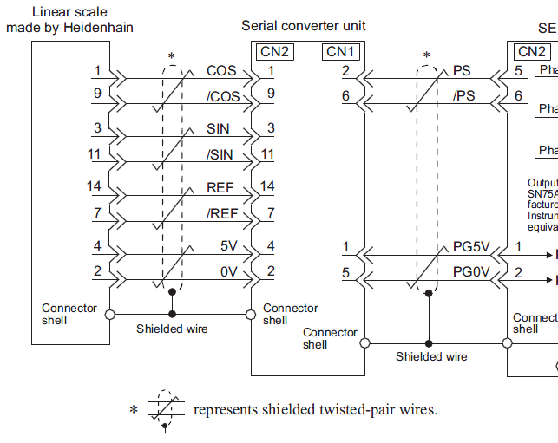
Encoders from other manufacturers can be used; the wiring will need to be modified to match one Renishaw or Heidenhain format. The main requirement is that the encoder signal be 1Vpp sin/cos. The user will need to wire the encoder signals to match the serial converter.
Below are typical Renishaw and Heidenhain pin outs to Yaskawa serial converter units:
Figure 1 – REnishaw Figure 2 - heidenhain

