Yaskawa America, Inc. Introduces Compass™ 2 Software
The CNC Solution for the Yaskawa iCube Control™ Platform

Waukegan, IL, May 20, 2026 – The Drives & Motion division of Yaskawa America, Inc. is proud to announce the release of Compass™ 2, the CNC software solution for iCube Control™. Compass 2 is engineered to combine the scalability of an industrial PC for user interface and path planning with the real-time motion and logic control of Yaskawa’s iC9200 machine controller, providing machine tool builders with a highly optimized CNC control solution.

Compass 2 is optimized for CNC routers, delivering blazing fast G-Code processing, macro logic, and path planning for maximum productivity. Block look-ahead and high-speed contouring algorithms ensure high sustained feed rates, precise corner tolerances, and smooth, high-quality cuts.
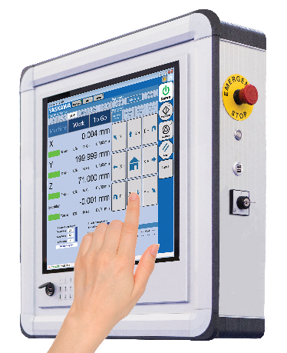
Customizing a machine’s user interface to optimize the user experience for the process and machine feature set is a great way to differentiate a machine from the competition. With Compass Designer, machine tool builders can use the included example user interface to start cutting quickly or create their own user interface. Compass Designer is used to create a fully customized CNC HMI as a Windows WPF application—without writing any C# code. The result is a stand-alone custom executable that includes Compass NC and built-in communications with the iC9200 machine controller.

Machine tool builders can also create custom G-Codes, M-Codes, and macro programs for tool changers, probing, and canned cycles. PLC integration is easy with the iCube Engineer library and starter project. Simply configure the Yaskawa Sigma-X servo axes and I/O, and the system is ready to cut.
.

About Yaskawa America, Inc.
Yaskawa America’s Drives & Motion Division manufactures industrial automation equipment, including low and medium-voltage variable speed drives, servo motors and amplifiers, machine controllers, spindle drives and motors, and low-voltage industrial switch products. The company’s Motoman Robotics Division makes industrial robots that can weld, assemble, cut, and handle goods for manufacturers.
Yaskawa products are used in a wide variety of industries, including automotive, building automation, machine tool, material handling, metal forming, packaging, pumping, water/wastewater treatment, plastics, rubber, solar, irrigation, and textile. Yaskawa America, Inc. employs more than 1,000 people in its headquarters in Waukegan, IL, its manufacturing facilities in Buffalo Grove, IL, and Franklin, WI, and in offices across the United States. For more information about Yaskawa, please visit our website at https://www.yaskawa.com.

