Yaskawa America, Inc. Introduces Innovative GA501 AC Microdrive
Ethernet-Ready, Out of the Box Solution.
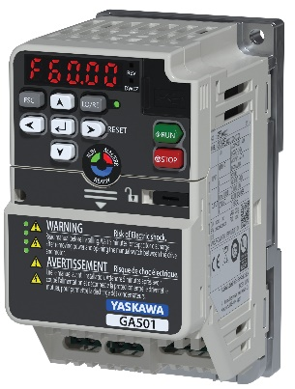
Waukegan, IL, March 16, 2026 – The Drives & Motion Division of Yaskawa America, Inc. is proud to announce the newest addition to our industrial AC drive lineup, the GA501 Industrial AC Microdrive with Embedded Ethernet!
Available for sale and shipment today, the GA501 is engineered for modern industrial automation and easily handles any industrial application, thanks to its embedded dual-port Ethernet capability.
Connectivity
The GA501 integrates seamlessly into your network via EtherNet/IP™, PROFINET®, Modbus TCP/IP, EtherCAT®, BACnet/IP®, or MECHATROLINK-4, all within a single AC drive. Reduce installation time with dual-port Ethernet connections, standard DIN rail mounting for up to 7.5 HP, and spring-tension I/O terminals. With support for all major industrial Ethernet protocols and topologies, the GA501 eliminates the need for additional hardware, reduces installation time, and simplifies system design.
Flexibility
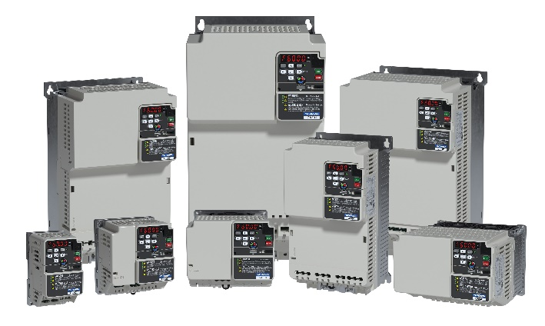
The GA501 can be part of your Industrial Internet of Things (IIoT) via a variety of industrial protocols. Select from the six on-board network protocols with a simple DIP switch.
Available ratings: IP20/ Open Type enclosure
- 240 VAC single-phase: 1/6 to 5 HP
- 240 VAC three-phase: 1/6 to 30 HP
- 480 VAC three-phase: 1/2 to 40 HP
Motor operation up to 40 HP includes:
- Induction (IM)
- Permanent Magnet (PM)
- Synchronous Reluctance (SynRM)
Ease of Use
Time is valuable. That’s why the GA501 is designed to let you program a unit without power applied, using the DriveWizard® Mobile application. With power applied, the innovative LED status ring and network status LEDs quickly and easily display drive status at a glance. The GA501’s world-class quality makes it the AC drive you can rely on for dependable, long-term operation.

For more information about the GA501 Industrial Microdrive, please visit: https://www.yaskawa.com/products/drives/industrial-ac-drives/microdrives/ga501-drive

About Yaskawa America, Inc.
Yaskawa America’s Drives & Motion Division manufactures industrial automation equipment, including low and medium-voltage variable speed drives, servo motors and amplifiers, machine controllers, spindle drives and motors, and low-voltage industrial switch products. The company’s Motoman Robotics Division makes industrial robots that can weld, assemble, cut, and handle goods for manufacturers.
Yaskawa products are used in a wide variety of industries, including automotive, building automation, machine tool, material handling, metal forming, packaging, pumping, water/wastewater treatment, plastics, rubber, solar, irrigation, and textile. Yaskawa America, Inc. employs more than 1,000 people in its headquarters in Waukegan, IL, its manufacturing facilities in Buffalo Grove, IL, and Franklin, WI, and in offices across the United States.
For more information about Yaskawa America, Inc., please visit: https://www.yaskawa.com

