Date | Customer | Job Name | P.O. / S.O.

Variable Frequency Drive (VFD)

iQpump®605 Mechanical Specification Submittal

(For NEMA 3R / UL Type 3R Rated Bypass Drives)

GENERAL
The iQpump605 (WM605) Bypass package provides a iQpump605 Drive in a NEMA 3R (UL Type 3R) enlosure, with a 3-contactor style bypass, allowing motor operation from either the drive or across the line. The iQpump605 features pump-specific application macros, an easy-to-read LCD keypad that provides Hand-Off-Auto interface, and a real time clock. These features make the iQpump605 perfect for most pump applications that require reliable motor control.
This drive has one control logic board and keypad for all horsepower ratings. Printed circuit boards employ surface mount technology, providing both high reliability, and small physical size of the printed circuit assemblies. The dual 32 bit microprocessors deliver the computing power necessary for complete three phase motor control in all variable-torque normal duty applications.
Operating Principle: Input three-phase AC line voltage is first rectified to a fixed DC voltage. Using pulse width modulation (PWM) inverter technology, the DC voltage is processed, to produce an output waveform in a series of variable-width pulses. Unique firmware algorithms optimize motor magnetization through control of voltage, current and frequency applied to generate a nearly sinusoidal output waveform.

STANDARDS
UL 508C (Power Conversion)
CSA 22.2 No. 14-10 (Industrial Control Equipment)
CE mark 2006/95/EC LVD
CE mark 2004/108/EC
IEC 61800-5-1 (LVD)
EN 61800-3
IEC 60529
IEEE C62.41
UL, cUL listed; CE marked
TuV SUD
WEEE
RoHS Compliant

BYPASS PANEL STANDARDS
UL 508A (Industrial Control Panels)
UL, cUL listed

ENVIRONMENTAL & SERVICE CONDITIONS
Ambient service temperature: -10°C to 40°C (14°F to 104°F)
Ambient storage temperature: -20°C to 60°C (-4°F to 140°F)
Humidity: 95% RH or less, non-condensing
Altitude: Up to 1000 meters (3300 feet), higher by derating
Service factor: 1.0
Vibration: 0.33 mm Displacement (10 to 20 Hz)
0.22 G (20 to 55 Hz)

QUALITY ASSURANCE
In circuit testing of all printed circuit boards is conducted to ensure proper manufacturing
Final printed circuit board assemblies are functionally tested via computerized test equipment
All fully assembled controls are tested with induction motor loads to assure unit specifications are met
The average MTBF (Mean Time Between Failure) is 28 years

DRIVE CONSTRUCTION
Input Section- The drive power input stage converts three-phase AC line power into a fixed DC voltage via a solid-state full wave diode rectifier with MOV (Metal Oxide Varistor) surge protection. An internal 3% DC bus reactor at ratings of greater than 30HP reduces harmonics (optional at smaller ratings).
Intermediate Section- The DC bus maintains a fixed, filtered DC voltage with short circuit protection as a DC supply for the drive output section. The DC bus is monitored by drive diagnostic logic circuits to continuously protect and monitor the power components.
Output Section- Insulated Gate Bipolar Transistors (IGBTs) convert DC bus voltage to a variable frequency, variable voltage PWM sine-coded AC output to the motor. Use of IGBT devices allow motor noise at 60 Hz to measure less than 2 dB (@ 1 meter) above that resulting from across the line operation.
Available horsepower ratings:
208VAC: 1 thru 100 HP
240VAC: 1 thru 100 HP
480VAC: 1 thru 250 HP
Microprocessor based control circuit uses non-volatile memory (NVRAM) so all programming data is saved when the drive is disconnected from power
Current transformers detect the output current for motor control and protective functions
Multi-language 5-line 16-character LCD Hand-Off-Auto keypad with real time clock. Provides local programming, run/stop control, monitoring, speed reference and reset commands
Customizable display of readouts including output frequency, output voltage, output current, output power, DC bus voltage, PI feedback and fault status. Includes parameter settings copy backup function
Built-In real time clock for time/date stamping of fault events along with timer functions for starting, stopping and speed changes without the need for external controls
Removable I/O terminal board has backup memory. All parameter changes are automatically saved to both the main control board and the I/O board. Leave I/O wiring connected when replacing a drive
Easy to remove DC voltage heat sink cooling fans with programmable on/off control
USB Type B port for quick and easy PC Connection

PROTECTION
Output current overload rating: 110% of drive’s continuous current rating for 60 seconds
Output short circuit protection
Current limited stall prevention (overload trip prevention) during acceleration, deceleration, and run conditions
Optically isolated operator keypad controls
Fault display with time stamp storage of last 10 faults
Motor hunting prevention function
Electronic ground fault protection
Electronic thermal motor overload (UL approved) protects the motor while operating in drive and bypass mode
Motor current displays in both drive and bypass modes of operation as well as verification that the motor is running
Proof of flow/loss of flow detection in both drive and bypass modes
DC bus charge indication
Heat sink over temperature protection
Cooling fan operation hours monitor
Input/output phase loss protection
Line voltage sensors to monitor for brownout and blackout conditions with adjustable fault levels to ensure the proper settings pursuant to each application.
Reverse prohibit function
Short circuit withstand rating of 65kAIC RMS, 100kAIC RMS with optional breaker

OPERATION
Over 100 programmable functions with resettable factory pump presets
User parameter settings initialization for re-establishing project specific parameter settings
Output frequency and speed display can be programmed for speed-related and control indications including: Hz, RPM, % or custom units
Power loss ride-thru (2 seconds capable)
Time delay on start, peak avoidance
Drive accepts either a direct acting or a reverse acting speed command signal
Bi-directional speed search capability allows starting into a rotating load. Two types: current detection and residual voltage detection
Ramp-to-stop or coast-to-stop selection
Auto restart capability: 0 to 10 attempts with adjustable delay time between attempts
One custom selectable Volts/Hertz pattern and multiple preset Volts/Hertz patterns
Analog speed reference signals have adjustable bias and gain
Automatic energy savings, reduced voltage operation
While the drive is running, operational changes in control and display functions are possible including:
Hand/Off/Auto commands
Start/stop commands
Frequency reference command
Acceleration time (0 to 6000 seconds)
Deceleration time (0 to 6000 seconds)
Monitor displays
Remove the operator keypad

PRODUCT FEATURES
Displacement power factor: 0.98 throughout the motor speed range
Drive efficiency: 96% at half-speed; 98% at full-speed
Starting torque capability: 150% from 3 Hz
Speed control range: 40:1
Carrier frequency: adjustable from 1 kHz to 15 kHz
Input phase insensitive; sequencing of the three phase input is unnecessary
Voltmeter, ammeter, kilowatt meter, elapsed run time meter and heatsink temperature monitoring functions
Two internal (PI) Controls:
- Drive internal PI closed loop control with selectable engineering units
- Independent PI control of external devices
Differential PI feedback feature
Sleep function in both closed loop and open loop control
Feedback signal low pass filter
Optional network communications include:
EtherNet/IP
EtherNet/IP dual port
Modbus/TCP
Modbus/TCP dual port
BACnet MSTP
APOGEE/METASYS
Self-regulating lead/lag control for multiple drives (up to 5 pumps)
Drive/motor alternation control (share motor run time for lead drive/motor)
Up to four PID setpoints
Enhance pump control features:
Easy sleep/wakeup PID setup
No flow/deadhead protection
Submersible motor thrust bearing control
Automatic system restart
Sleep boost
Low and high pressure feedback detection
Power loss utility start delay timer
Loss of prime (LOP)/pump dry-run protection
Pre-charge control (controlled pipe fill)
Optional dual transducer feedback for redundancy
Impeller de-scaling/de-ragging control
Low city, low/high water alarm digital input selections
Draw down start level selection for PID setpoint
Contactor Multiplexing features:
Stage/de-stage control – add/remove drive based on feedback or output frequency
Speed reduction after lag pump staging
Setpoint boost after de-staging
Hard current limit
Back spin timer
Feedback signal loss detection with selectable response
Feedback signal inverse capability
Feedback transmitter power supply: 24 VDC, 150 mA
Input and output terminal status monitors
Diagnostic fault/alarm indicators with dedicated contacts
S-curve soft start / soft stop capability
Network communication loss detection with selectable response
Up/down motor operated pot (MOP) floating point control
17 preset speeds
Critical frequency rejection capability: 3 selectable, adjustable bandwidths
Dynamic noise control function for quiet motor operation
Programmable security code for operator keypad lockout
Run/stop command methods:
Terminal strip (2-wire or 3-wire)
Network communication
Operator keypad
Speed reference (speed command) methods:
0 to 10 VDC or -10 to 10 VDC (20 kΩ)
4 to 20 mA or 0 to 20 mA (250 Ω)
0 to 32 kHz pulse train
Network communication
Operator keypad
Eight programmable multi-function digital input terminals (24 VDC, sinking or sourcing, internal/external power supply) providing 60+ programmable functions including:
Multi-step speed references
Jog commands
PID control enable/disable
Three programmable multi-function digital output terminals (2 Form-A and 1 Form-C relays, 1 A @ 250 VAC / 30 VDC) providing 50+ functions including:
During run
Drive ready
Speed agree
No load detection (broken belt/shaft alert)
One fixed Fault output relay (Form-C, 1 A @ 250 VAC / 30 VDC)
Three programmable multi-function analog input terminals (individually selectable for 0 to 10 VDC, -10 to 10 VDC, 4 to 20 mA, or 0 to 20 mA) providing 15+ functions including:
Frequency reference
PID setpoint
PID feedback
Two programmable multi-function analog output terminals (individually selectable for 0 to 10 VDC, -10 to 10 VDC, or 4 to 20 mA) providing 20+ functions including:
Output Frequency
Output Current
Output Power
One programmable multi-function pulse train input terminal (0 to 32 kHz) providing several functions including:
Frequency reference
PID setpoint
PID feedback
1 fixed Fault output relay (Form-C, 1 A @ 250 VDC / 30 VDC)
1 built-in RS-485, 115.2 kbps Modbus/Memobus network communication port
Stationary and rotational motor auto-tuning
Overexcitation braking function stops the motor in up to half the normal time
Motor preheat function
Upgradeable drive firmware via PC program
Heat sink over temperature speed fold-back feature
Bumpless transfer between local and remote modes

BYPASS FEATURES
Bypass and drive are factory assembledBypass and Drive input/output contactors
Lockable Main Input circuit breaker (65kAIC panel rating)
Thermal motor overload relay, class 20
115 VAC control transformer, fused
Drive H/O/A keypad used for bypass control
Selectable energy savings and harmonic reduction mode.
No load detection (loss of load) fully monitored in drive and bypass modes
Door mounted control keypad with LCD display for “Control Power”, “Drive Ready”, “Drive Run”, “Drive Selected”, “Drive Fault”, “Drive Test”, “Bypass Selected”, “Bypass Run”, “Motor OL”, ”Safety Open” “BAS Interlock”, “Auto Run”, Auto Transfer”, “Hand Mode”, “Off Mode”, and “Auto Mode”
7 programmable multi-function digital input terminals (24 VDC, 8 mA) providing 60+ programmable functions including:
Customer Safeties
Preset Speed
PI control enable / disable
4 programmable multi-function digital output terminals (Form-C relays, 2 A @ 120 VAC / 24 VDC) providing 50+ functions including:
Hand / Auto Status
Contactor Control for External Bypass
Overtorque/undertorque detection
Auto speed reference (speed command) methods:
0 to 10 VDC (20 kΩ)
4 to 20 mA (250 Ω)

Model Number Configuration
Step 1. Complete the Base Number for the voltage and current.
Step 2. Add the Option Code letter for each required option. If an option is not wanted, no character is inserted at that position. 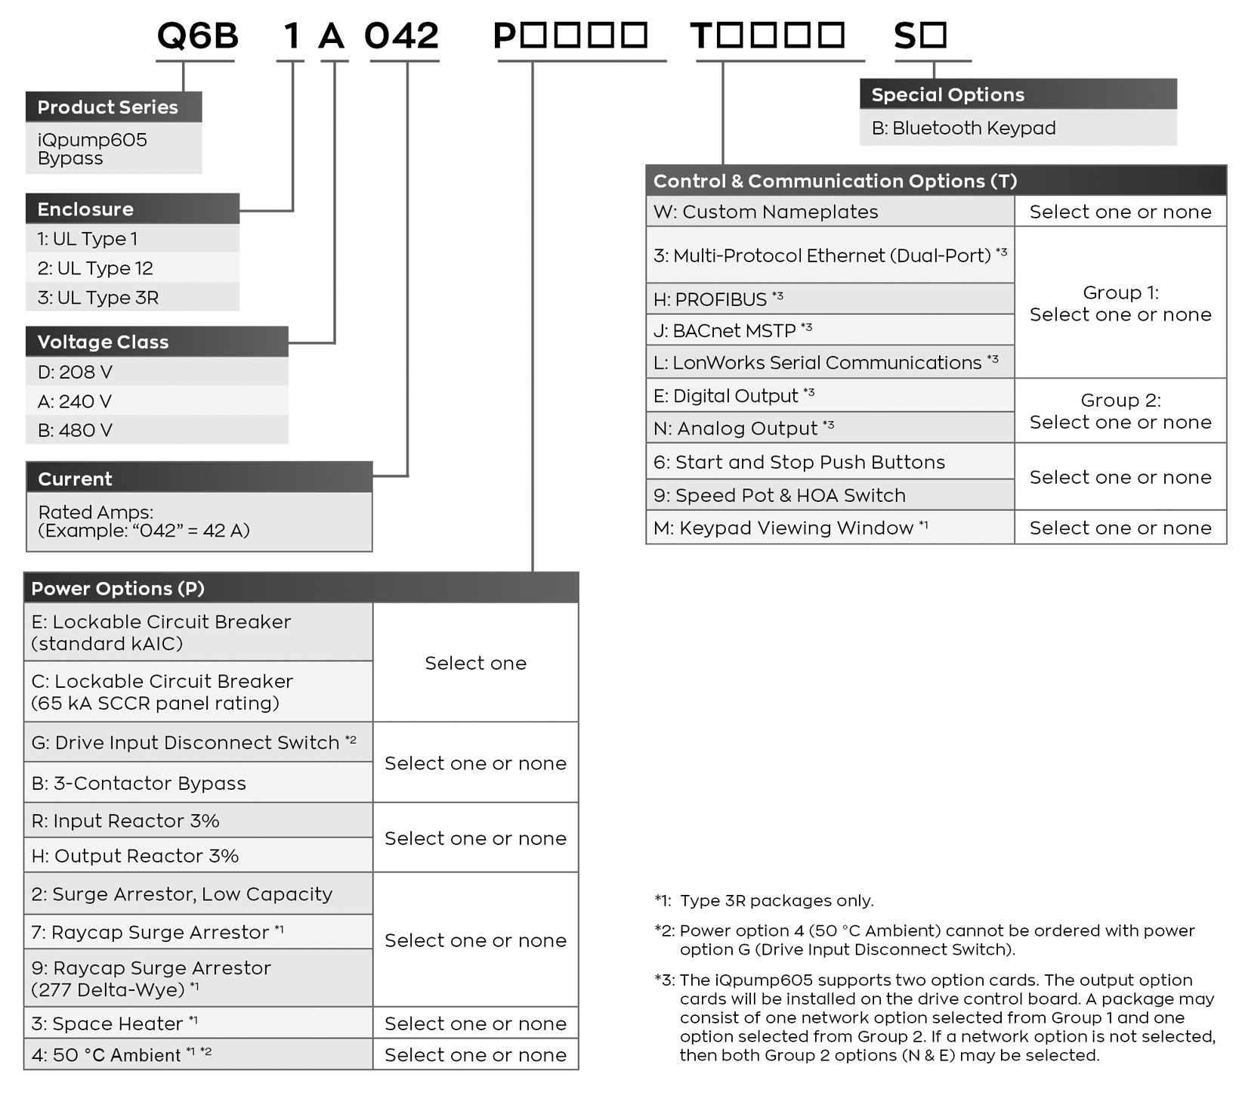

ENCLOSURE TYPE
[3] NEMA 3R (UL Type 3R) Enclosure
VOLTAGE
[D] 208 volt models, 200 to 240 VAC (+10/-15 %); 50/60 Hz (+/-5%)
[A] 240 volt models, 200 to 240 VAC (+10/-15 %); 50/60 Hz (+/-5%)
[B] 480 volt models, 380 to 480 VAC (+10/-15 %); 50/60 Hz (+/-5%)
[P] POWER OPTIONS
MAIN INPUT DISCONNECT (Choose None or One)
[E] Circuit Breaker Disconnect (Standard AIC)
[C] Circuit Breaker Disconnect (High AIC)
ADDITIONAL POWER OPTIONS (Choose None or One)
[G] Drive Input Disconnect Switch
[B] 3-Contactor Bypass
REACTOR (Choose None or One)
[R] 3% Line Reactor
[H] 3% Load Reactor
ADDITIONAL POWER OPTIONS (Choose None or One)
[2] Surge Arrestor, Low Capacity
[7] Raycap Surge Arrestor
[9] Raycap Surge Arrestor (277 Delta-Wye)
ADDITIONAL POWER OPTIONS (Choose None or One)
[3] Space Heater
ADDITIONAL POWER OPTIONS (Choose None or One)
[4] 50°C Ambient
[T] CONTROL OPTIONS
[W] Custom Nameplates
NETWORK COMMUNICATION (Choose None or One)
[3] Multi-protocol Ethernet (Dual Port)
[H] PROFIBUS
[J] BACnet MSTP
[L] LonWorks
I/O OPTION CARD (Choose None or One)
[E] Digital Output
[N] Analog Output
CONTROL OPTIONS (Choose None or One)
[6] Start/Stop PBs
[9] Speed Pot/HOA SS
ADDITIONAL CONTROL OPTIONS (Choose None, Any, or All)
[6] Start/Stop PBs
[9] Speed Pot/HOA SS
ADDITIONAL CONTROL OPTION (Choose None or One)
[M] Keypad Viewing Window
SPECIAL OPTIONS
[B] Bluetooth Keypad

Tag:
Model Number:
HP:
Amps:
Volts:

