There are two cases when this error may occur: If the library cannot be found on the PC or if the library is marked as open.
Case 1: Library not found
If the library cannot be found, the following message will be displayed.
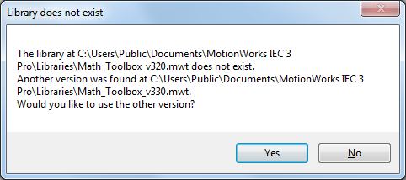

In this case, accept the newer version or find and add the required library to the folder shown manually. If the library cannot be found, you can download it from www.yaskawa.com.

Case 2: Library is marked as open
The second case occurs when the user library is found but cannot be added to the project.
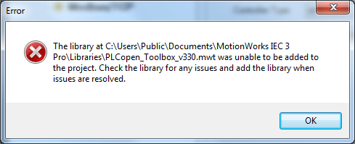
This is most likely caused by the library being marked as open. To correct this problem, open the library in MotionWorks IEC, save the project, then reopen the original project.
After this, you must manually add the library into to your project.

