How do I use the "Toggle Boolean" feature of MotionWorks IEC Pro to simulate latched HMI pushbuttons?
An undocumented feature of the Toggle Boolean (TB) mode makes it possible to latch a BOOL contact ON rather than the normal momentary behavior. This is often useful during testing, demonstration, or start-up before all of the ancillary equipment is programmed and connected.
To implement this, create a ladder network with the desired TB variable (example below: EnableTest) as a normally closed contact and connect to the desired coil.
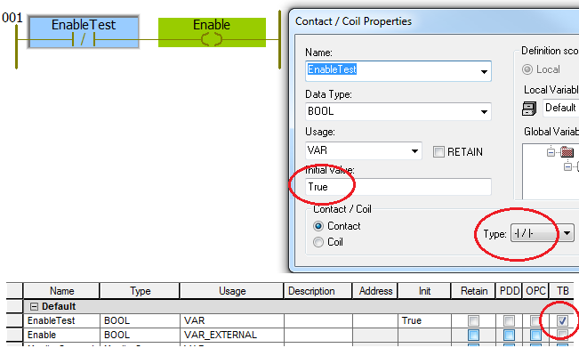
During creation of the “EnableTest” variable, set the Initial Value = “True” and select normally closed contact type. As described in the Toggle Boolean help go to the appropriate variable declaration worksheet to set the ability to use TB mode by checking the box. One can confirm the initial value (Init) of “True” as well.

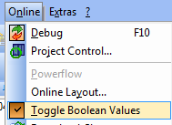Finally, while in Debug mode from the Online menu, enable the Toggle Boolean behavior. This is confirmed with a checked checkbox next to the menu value. The TB enabled variables will be highlighted with a yellow background. Left clicking on a TB variable will change its state and remain in that state until clicked again.

