Q: In MotionWorks IEC Hardware Configuration, why are the Mechatrolink III axes displayed as offline when the ServoPacks are powered up with no alarms?
A: If the controller had any problems discovering the ServoPacks when powering up, the ServoPacks may have to be power cycled. The first remedy to try is power cycle the entire system. For the axes to be displayed as online, they must have been powered up before the MWiec controller. Since the controller takes several seconds to complete its power up phase, powering the entire system at the same time is fine.

If there is no Startup configuration, or if any of the hardware may have been changed, check the switch settings for all ServoPacks. All Mechatrolink III devices must be configured for 48 byte packets and the assigned node numbers must be unique and in the range of 3 to 64.
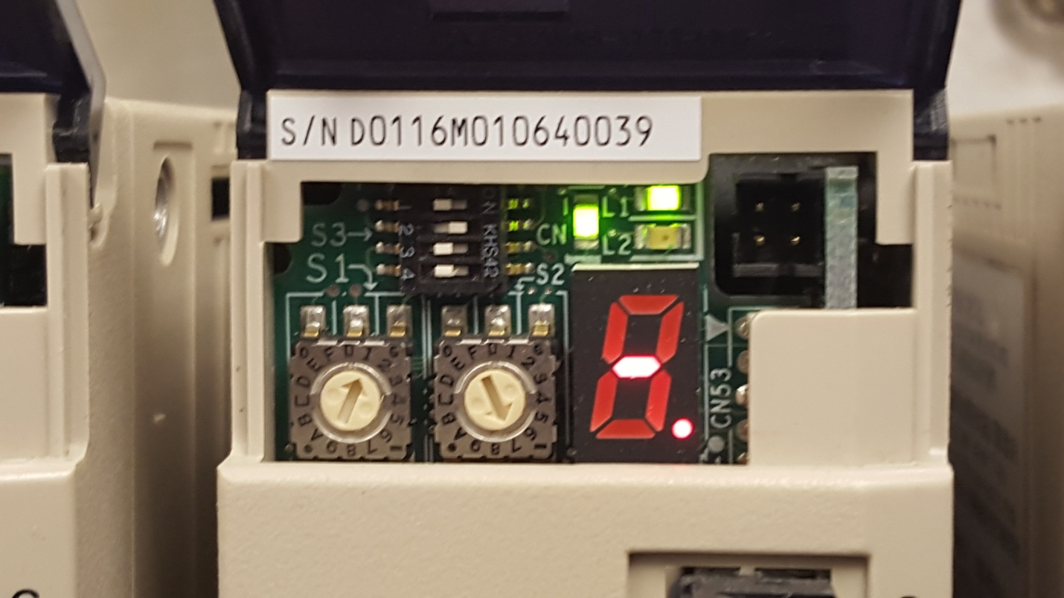
Address setting
Amplifier switches configured for 48 byte packet
Next, confirm that all cables are connected correctly. The MP3000iec controllers and ServoPacks have LEDs in the Mechatrolink connector that are lit when a cable is plugged into the socket that is connected to an active node. When all devices are powered, check the LED status in all connectors.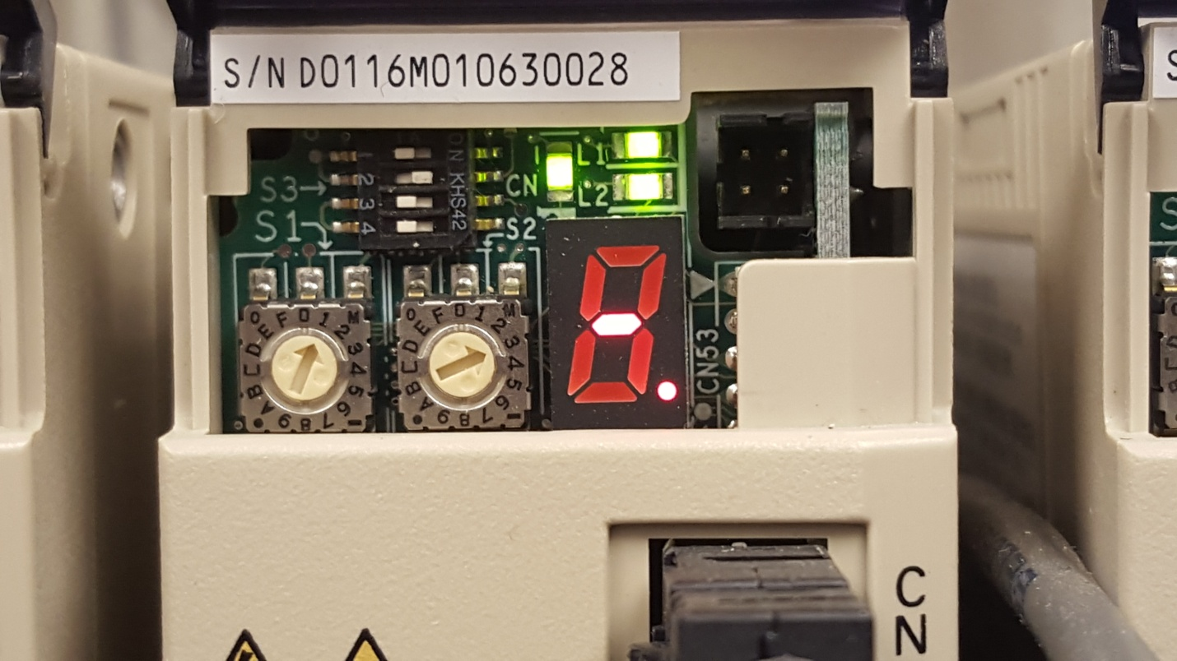
Amplifier showing 2 active M-III connections
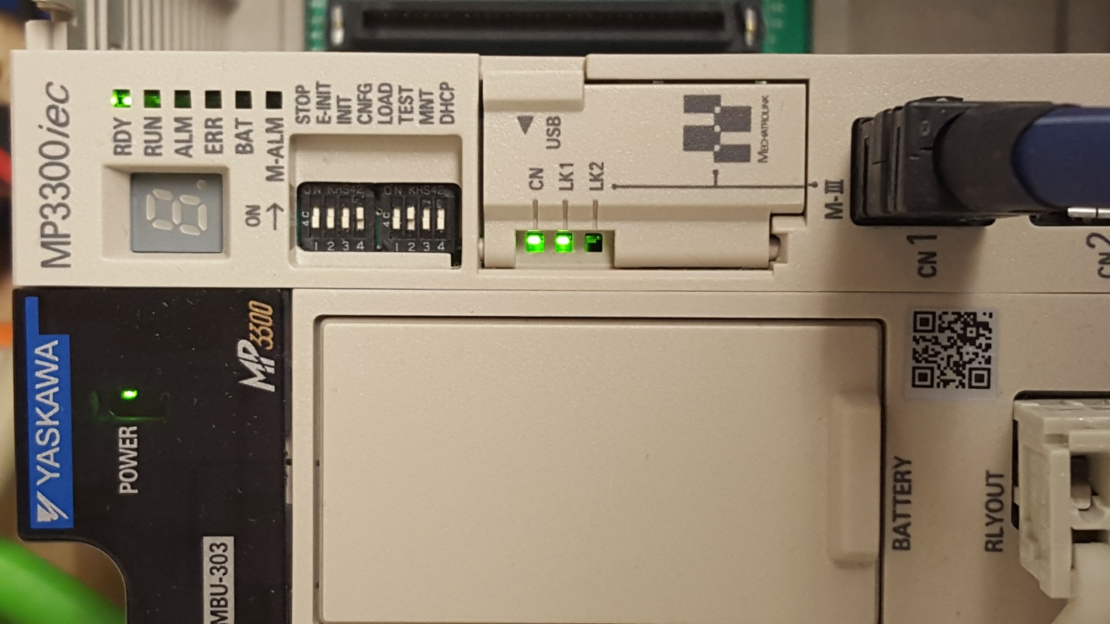
Controller showing 1 active M-III connection
Finally, if there is a Startup configuration and all the hardware is configured correctly, check the configured response times. The configured response times must be very close to the measured response times. Values that are slightly lower, or much higher than the measured response times may cause the controller not to connect to these nodes. The measured response times can be viewed by allowing doing the following:
1) Using the web server, delete the Startup Configuration
2) Set the MWiec controller to self configure (CNFG DIP switch must be ON)
3) Using the Hardware Configuration, connect with a new project, or connect with an existing project and use the discovered configuration.
4) Refer to the Mechatrolink-III node in the Hardware Configuration to view the measured response times.
See the attached document for pictures showing switch settings and status LED’s and view the Mechatrolink III webinar for more information:

