How does one manage the order of user libraries in a MotionWorks IEC project?

The order of user libraries is important to consider when multiple user libraries will be included in a project. A user library containing Data Types, functions, or function blocks that are used by another user library must appear higher in the list than the libraries that reference those tools. Once libraries are added to a project, their order in the list cannot be changed, however the insertion location can be controlled. You may have to delete and re insert the user library to attain the desired ordering. There are two ways to control the insertion of a library into a project.

- Right-Click on Libraries folder
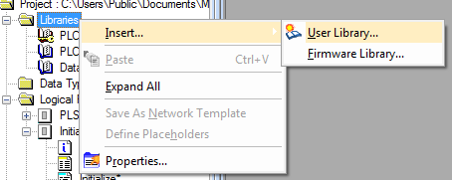
  - Inserting from this point will add the user library to the end of the list.

- Right-Click on a library that already exists in the project.
  - For example, Right-Click on PLCopen_Toolbox_v205.
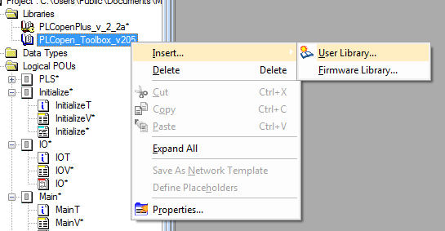
  - This will insert the new library above the selected library.
