Question: In MotionWorks IEC Hardware Configuration, is it possible to move a configured axis from one node number to another?

Answer:
Although the node number is not editable and therefore cannot be moved directly, the desired effect can be achieved by copy and pasting parameters.

First create a new device of the same type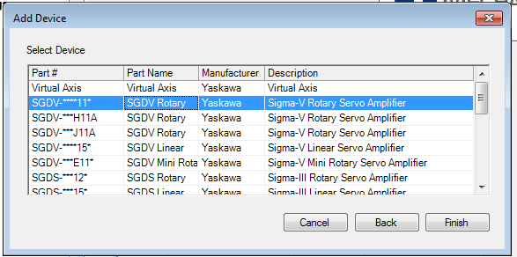

and assign the node the new node number.

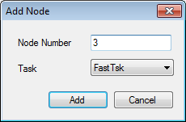

Next, right click on the old device and select Copy Parameters

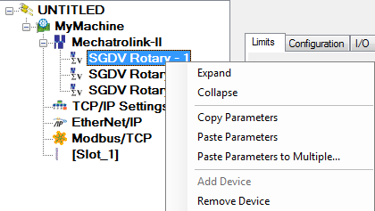

Then, right click on the new device and select Paste Parameters.

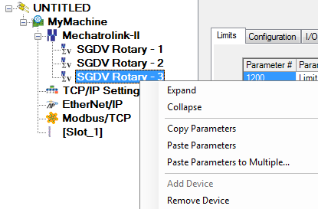

Finally, remove the old device.

