Questions: In MotionWorks IEC, how can MECHATROLINK-III be configured to run at the fastest update rate? How can a MECHATROLINK-III network be configured to be robust to cabling differences?

Answers:
To run at the fastest update rate, start with a new project and a controller restored to factory defaults, and follow these steps:

- Connect the drives to the MPiec Controller trying to minimize the number of nodes strung in a line. For example, if there are eight nodes, use two lines of four by using both MECHATROLINK–III connectors on the MPiec Controller. The network can operate faster than one line of eight. Using a MECHATROLINK-III hub can further improve performance.
- Power on the MPiec Controller with the CNFG switch ON.
- In MotionWorks IEC, launch the Hardware Configuration, enter the IP address of the controller, press the “Connect” button, and then choose the auto-discovered configuration.
- Next, select the “MECHATROLINK-III” from the configuration tree at the left of the screen. This window shows the configured and measured response times for each node as well as a chart show the communication cycle usage.
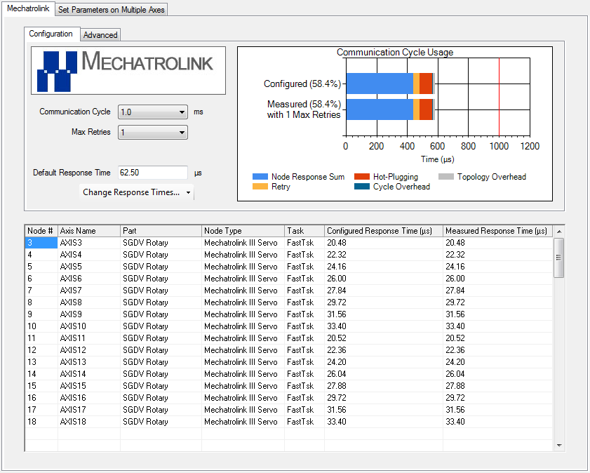
- By default, the Configured Response Time is set to the Measured Response Time, which is the fastest configuration. If the Configured Response Times are modified, press the “Change Response Times…” button and select “to Measured Response Times.”
- Select the minimum allowable value in the “Communication Cycle” drop down, which in the example shown is 1.0 ms for this configuration.

While this configuration allows MECHATROLINK-III to run at the minimum cycle time, changes in MECHATROLINK cabling may prevent the controller from communicating with some nodes. For example, Node 3 above has a measured and configured response time of 20.48 microseconds because it’s physically the first node connected to the MPiec Controller. If instead, the cables are changed so that Node 3 is the furthest from the controller (in distance and/or number of devices the signal must pass through) but the Configured Response Time does not change, then the controller will not be able to communicate with it.

Using the project above as a starting point, the system can be configured to be robust to cabling changes by following these steps:
- Press the “Change Response Times…” button and select “to Maximum Measured Response Times.” Notice that total configured time in the “Communication Cycle Usage” chart increases. 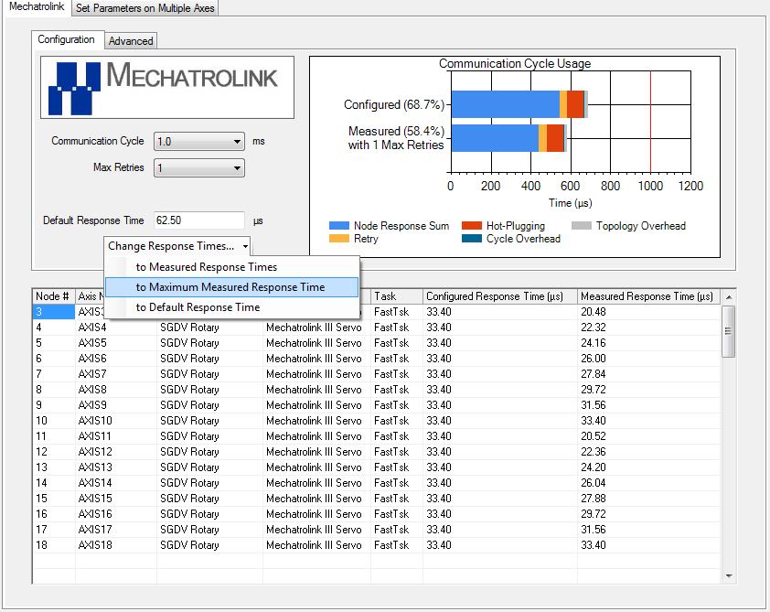
- Again, select the minimum allowable value in the “Communication Cycle” drop down. In this example, the minimum Communication Cycle is still 1.0 ms, but if more axes are added to the system it could increase.

The MECHATROLINK-III configuration tab has some additional capabilities. First, the Configured Response Times can be set back to the Default Response Time, which can be a useful first step if the topology completely changes and the controller cannot communicate with some nodes. Second, the “Configure Response Times” values are editable, so expected response times can be selectively increased to account for specific variations in cabling. By analyzing the “Communication Cycle Usage” chart, spare communication bandwidth can be used to increase robustness to cabling changes without affecting the cycle time.

