There are two ways to reset an MPiec controller to factory defaults, one using a web browser and the other with MotionWorks IEC’s Hardware Configuration.
Web Browser Method
Over the course of time, the MPiec controllers have included two web interfaces. Starting with firmware version 3.2, the web interface shown in this document was added. Controllers with firmware older than 3.2 supported the original web interface for Windows Internet Explorer, and also contained the ability to reset the controller to factory defaults. Connect to the MPiec controller using a web browser and enter the username and password. The default username is “Admin”, the default password is the Software Platform (listed on the MPiec home page) minus the “iec”. For example, for the MP3300iec shown below, the Software Platform is “MP3300iec” so the default password is MP3300. This applies to all MPiec controllers except the MP2310iec for which the password is the same as for the MP2300Siec, “MP2300S”.
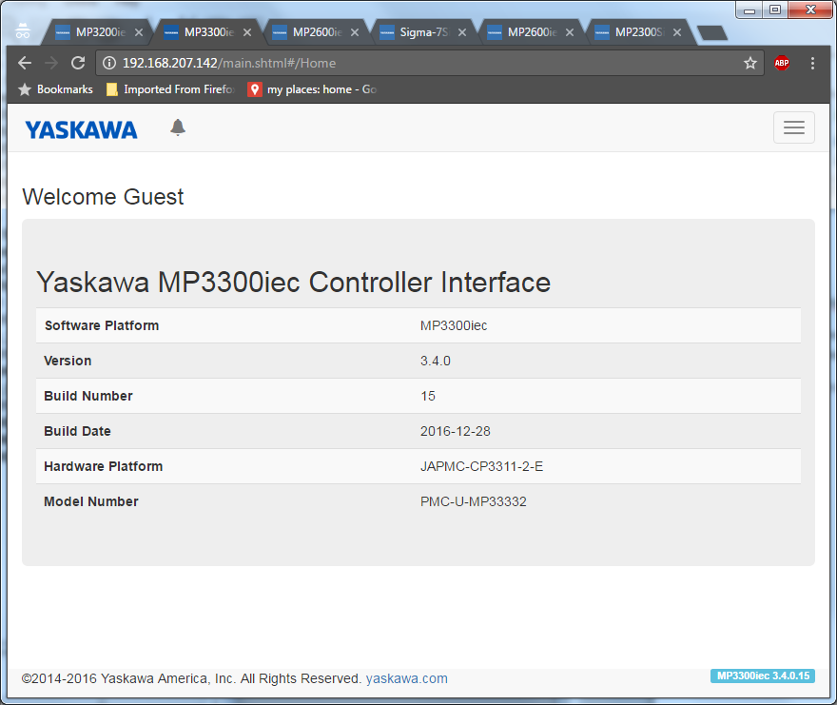
Once logged in, navigate to the Setup -> Archive page.

On the Archive page, choose “Delete” and then click on Delete in the confirmation screen. 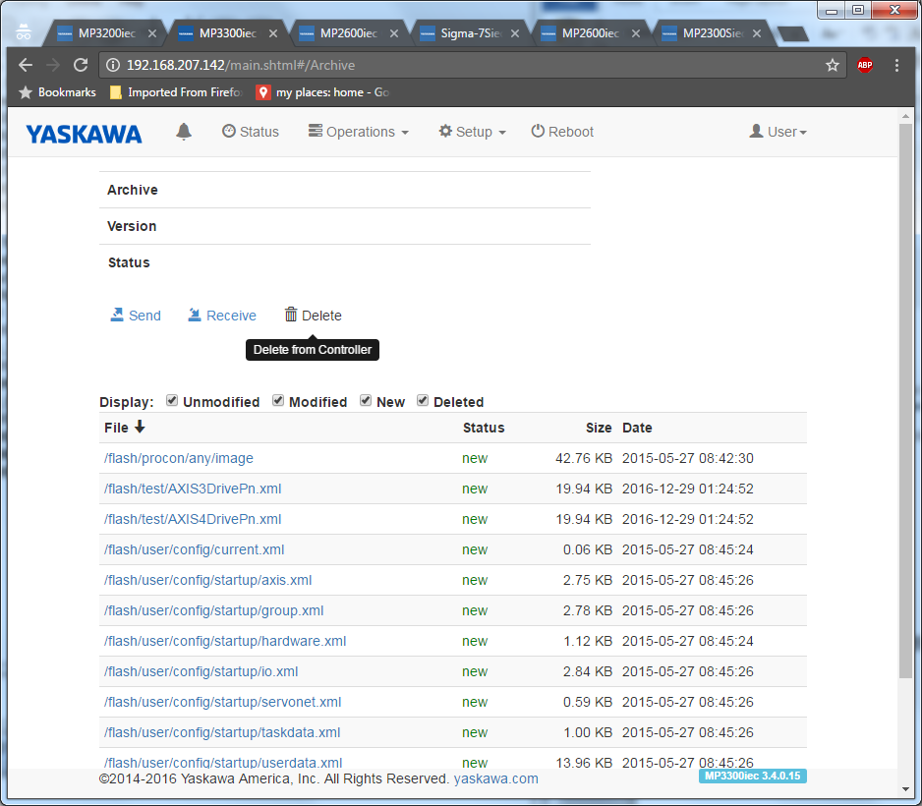
To complete the restoration to factory defaults, reboot the controller.
Click on Reboot at the top of the screen and then click Reboot again in the confirmation screen.
Using MotionWorks IEC Hardware Configuration
To reset an MPiec Controller to factory defaults using Hardware Configuration, open MotionWorks IEC, open the project, or start a new project, and click on the Hardware Configuration icon.
Click the Online menu and select “Controller Configuration Utilities.”
Select “Restore controller to factory defaults and reboot the controller.”
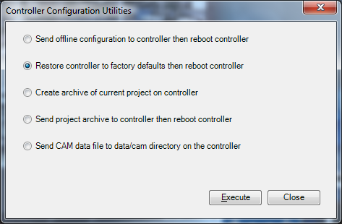
Tip: If the Restore controller to factory defaults and reboot the controller is greyed out, then there no Startup configuration saved on the MPiec controller. In this situation, use the web browser method, or save a configuration onto the MPiec controller first.
Click “OK” on the warning dialog
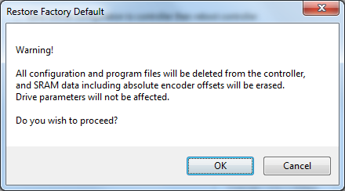

Click “Yes” on the reboot dialog.

Restoring a controller to factory defaults means that all application flies are deleted from flash memory. The firmware is not affected, nor the battery backed SRAM, which may contain absolute encoder offsets. To clear the SRAM, use the Init SRAM function in the web interface.

