Pn600 (regen capacity) can be modified in three ways:
1) From the front panel of the servopack
2) From the servopack setup & confituration software "SigmaWin"
3) From the controller software "MotionWorks IEC" configuration tool

*****************************************************************
Below is the procedure for setting this parameter through MotionWorks IEC:

Make sure that the regen wiring has been done as specified in the drive manual. Refer to section 3.7 of the Sigma-5 Series Servo System User’s Manual:
http://partner.yaskawa.com/site/dmservo.nsf/aa8198da5462fcbe86256c59004e4bcb/86256ec30069fdef862573a0005490cd/$FILE/Sigma-5%20design%20manual_M-II_R_E.pdf

and

https://partner.yaskawa.com/site/dmservo.nsf/SearchV/86256EC30069FDEF862574B900723977?OpenDocument&Source=SearchResultPage

for more details.

Go online with the configuration tool

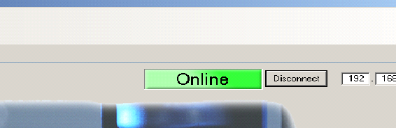
Once online with the Configuration Tool, select the desired drive on which the regen capacity needs to be set.

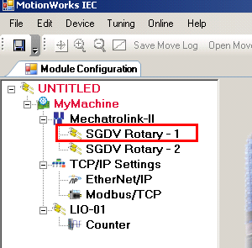

Under the Function tab for the axis with the regen resistor, Pn600 can be entered. Note that the value to be entered is in Watts and not in 10 Watts like it is on the Yaskawa drive.

