Related Products:
MWiec, MWiec Pro

Hardware configuration launches but does not appear after using dual displays, how can I see it?

With the advent of inexpensive LCD display and PCs that support this method, it is nice to have all of the real estate when doing off-line development. Typically some tools are put on one screen and others on another screen. When you go on-site to do the deployment/start-up of the application the application appears to launch, but it can’t be seen. If you forgot to move all of the information back to the primary screen before disconnecting it may launch in the space where the secondary screen was located.

This can be easily recovered from, follow these steps to move the application back to your primary screen:
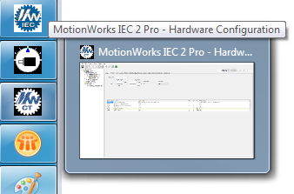
- Select the application on the start bar (or alt-tab to the “hidden” application)

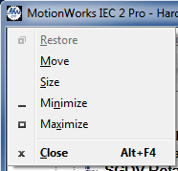
- Press Alt-Space Bar, this launches the following menu (which won’t be seen) as the application is on real estate not in the current display field.

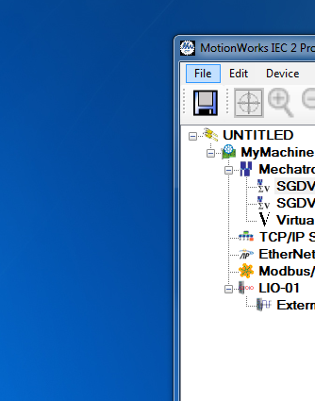
- Press “M” for move; Press the left arrow on your keyboard; Finally use your mouse to drag the application back to your primary display. Below you can see the application being moved back to the primary display from the (Phantom/un-connected) display location.

