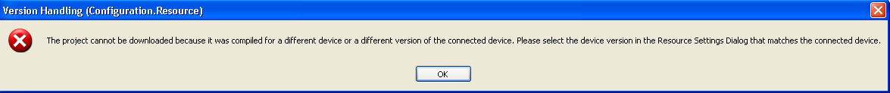

The above message indicates that the “Build Settings” for a Configuration> Resource> is higher than the corresponding build setting of the firmware on the target MPiec controller. For example, if a project compiled in MotionWorks IEC 2.1.0, *which uses build setting 2.1.0 by default*, is downloaded into a controller with firmware version 2.0.0, the message will be displayed. MPiec Build Settings change from time to time, and provide synchronization of major feature differences between the complier and firmware. In the example described here, MotionWorks IEC 2.1.0 includes the new firmware library called YDeviceComm. Controllers with firmware less than 2.1.0 do not have support for the functions supplied in the YDeviceComm firmware library.

Remedy:

To proceed with the download, change the Build Settings in the Project Tree Window (Configuration> Resource> Settings) to MPxxxxiec 1.2.1. Once the software build setting is changed to a value equal to or lower than the firmware version on the controller, and the project is recompiled, the project should be ready for download.



Determining the controller firmware version:

The firmware version of a controller can be obtained by launching the web server of the controller. The welcome page states the firmware version.

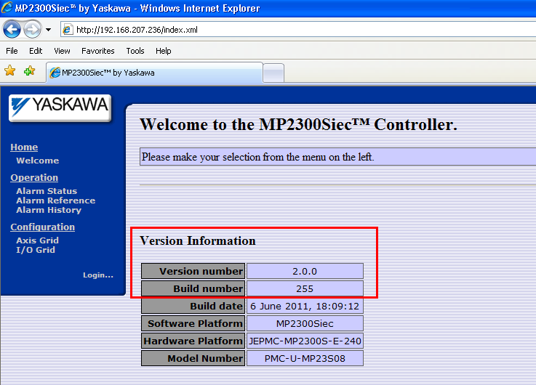

Firmware upgrades are available at:

[www.yaskawa.com/iecfw](https://www.yaskawa.com/iecfw)