|  |
| --- |
| How to Cut Chiller Energy Costs by 30% |
| Pre-packaged retrofit cuts centrifugal compressor chiller energy costs by 30% while reducing required maintenance and extending operating life at Duke Realty Corporation’s 19 story office building in Clayton, MO. |

|  |
| --- |
| Michael Grant, Regional Drive Specialist  Yaskawa America, Inc. |

Introduction

In January of 2012, Yaskawa America Inc., and Air Masters Inc. of Fenton, MO reported that they had successfully applied and installed multiple Chiller Optimization Packages (COP) in the St. Louis area.

The reason for these COP retrofit installations is that Chillers typically represent the single largest consumer of power in buildings. Therefore, they are a logical place to consider for reducing energy consumption/ costs.

This article examines chiller applications, opportunities to increase their efficiency, how a COP retrofit solves the problem of wasted energy, and provides results from a 2015 case study of an actual 2013 COP installation at Duke Realty in Clayton, MO.

Improving Chiller Efficiency

The chiller is typically the single largest consumer of power in a building, so it’s a logical place to look for reducing energy costs. Chillers use excess energy when their compressor runs at full-rated constant speed, a wasteful and unnecessary operating condition, as most chillers operate at partial load or off 99% of the time. The compressor motor in a chiller is typically quite large, in the range of 150-600 HP, so money saved by operating the compressor motor more efficiently can add up quickly.

The best way to improve chiller compressor motor efficiency is by upgrading motor control from constant to variable speed using a variable frequency drive (VFD). Rising energy costs and electric utility rebates for VFD upgrades coupled with falling prices for large horsepower VFDs have reduced payback times to as little as one year. But, chiller compressor motor VFD retrofits have been somewhat complex projects for a variety of reasons, causing many to postpone retrofits and forego savings.

To address this issue, the Drives Division of Yaskawa America ([www.yaskawa.com](http://www.yaskawa.com)) teamed up with Air Masters ([www.airmasters.com](http://www.airmasters.com)) to create a pre-packaged solution that is economical to purchase, easy to install and simple to operate. Their solution is the Chiller Optimization Package (COP), and it can be retrofitted to existing chillers regardless of brand or size.

The COP is most effective when retrofitting centrifugal compressor chillers, but it can also be applied to other types of chillers including those with reciprocating, rotary scroll and screw compressors. Centrifugal compressors make up the bulk of the chiller market with about 70% market share, so the COP solution addresses the largest chiller market segment in the most efficient manner possible.

To understand how the COP works, it’s important to first examine chiller operating details.

Chilling Out with the Refrigerant Cycle

A chiller transfers heat from an area where it is unwanted to a place where it is unobjectionable. This is accomplished by using a refrigerant exchange medium and a compressor to perform the required heat transfer. This process is known as the refrigerant cycle, and is depicted in the diagram below.

The refrigerant cycle employs four main components: a liquid metering device, an evaporator, a compressor and a condenser.

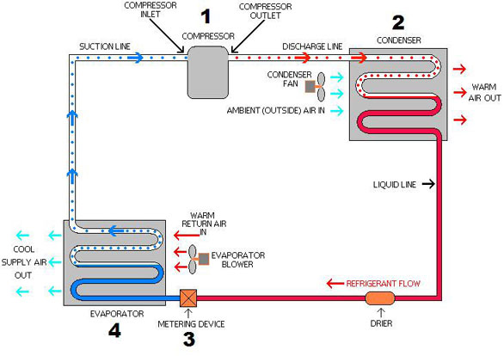

The Refrigerant Cycle

The cycle begins with the refrigerant in a liquid state at high pressure in the condenser. From the condenser, the liquid refrigerant flows to the evaporator with flow regulated by a metering device. The evaporator is at a lower pressure than the condenser, so flow is naturally induced from the higher to the lower pressure area.

In the evaporator, the refrigerant changes state from liquid to gas by absorbing heat from the area where it is unwanted, typically called the load. The refrigerant gas is then discharged from the evaporator to the compressor, which raises its pressure.

Next, the high pressure gas discharges the unwanted heat to the unobjectionable place, typically the atmosphere, by changing states back from a gas to a liquid in the condenser. The refrigerant then flows from the condenser to the evaporator, and the cycle begins again.

Now that we have a basic understanding of the refrigerant cycle, we can look at exactly how the COP improves refrigerant cycle and overall chiller efficiency.

COP Solves the Crime of Wasted Energy

To understand how a COP-retrofitted chiller saves energy, consider the two factors that most affect chiller energy consumption. The first is the load, and the second is entering condenser water temperature. A reduction in either of these two factors will save energy, but load is not a controlled parameter and is instead a function of building demand, so the COP instead focuses on efficient reduction of entering condenser water temperature.

A chiller with a constant speed compressor motor reacts to lower load or lower entering condenser water temperature by closing its pre-rotational vanes, which reduces refrigerant flow and saves some energy. However, as the vanes close, they create frictional losses, reducing chiller efficiency and limiting energy savings.

The COP sequences the vanes to a closed position before the compressor motor starts. The unloaded chiller is then given a command to make a controlled acceleration to full speed, usually 60 Hz or about 3600RPM. This control sequence keeps starting torque low by providing a gradual and controlled acceleration of the compressor, thereby increasing mechanical drive and chiller system longevity while cutting required maintenance. The compressor motor soft start also reduces instantaneous power draw from the electric utility, often reducing demand charges.

The COP controller measures the difference between compressor suction and discharge pressure while dialing the vanes open. The lift temperature, the saturated compressor discharge temperature minus the saturated evaporator temperature, is measured as the vanes are simultaneously controlled to maintain the required chilled water set point for the condenser. A chiller has to maintain a certain minimum required lift temperature at all times.

Chiller compressor motor speed is then regulated to keep refrigerant velocity slightly higher than that needed to maintain the required lift temperature. For example, if the exiting condenser water temperature rises as load increases, the required lift will go up, thereby increasing chiller compressor motor drive speed.

Starting torque must be considered in selecting a drive, as refrigerant density is often much higher at start-up than at operating conditions. Typically, 160% of rated starting torque is provided by a standard motor starter or controller. The VFD’s inherent soft start eliminates this torque transient, so standard normal duty-rated AC drives can be used with the centrifugal compressor motor in the chiller, reducing VFD up-front cost.

In summary, a much more efficient way to adjust to changing load characteristics or lower condenser water temperatures is to vary the speed of the chiller compressor motor, as opposed to adjusting vanes or other mechanical flow control devices.

The COP is not only the most efficient way to operate a chiller, it’s also simple to implement. The COP consists of a VFD, sensors, a controller and a touch screen operator interface panel. COP installation consists of supplying power to the VFD, connecting the VFD to the compressor motor, installing and connecting the sensors, and connecting the vanes to the COP.

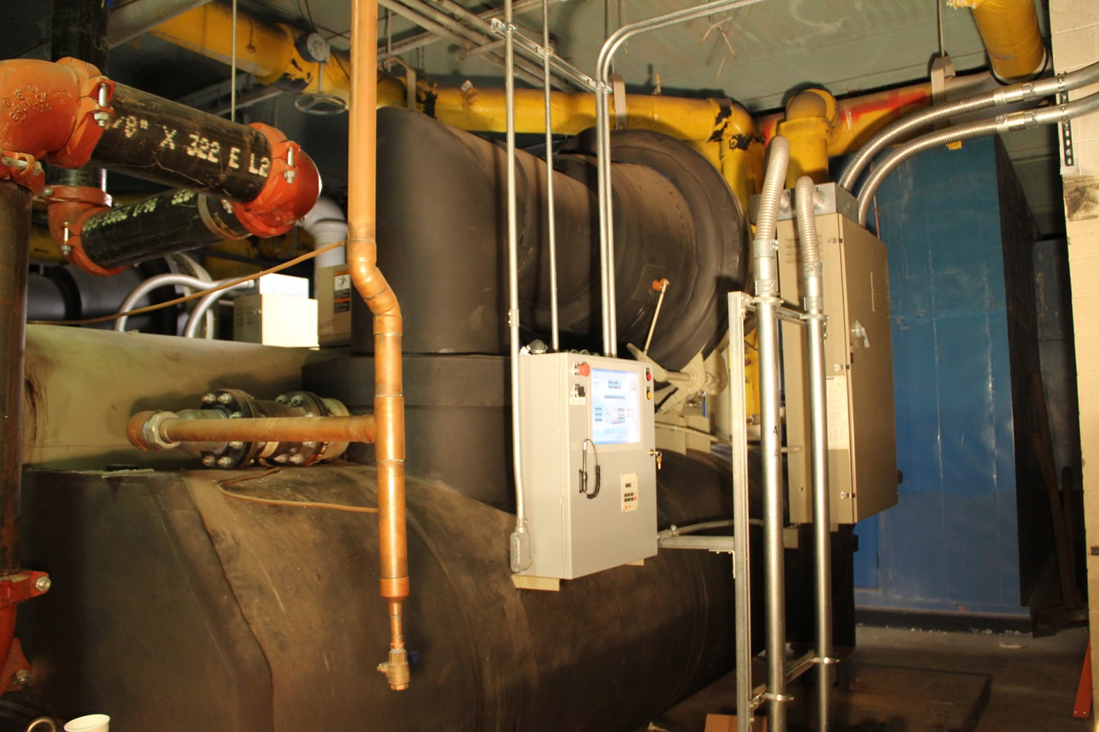

Image 1: Building maintenance personnel can easily monitor and control chiller operation from the touch screen using graphic icons and simple commands

As depicted in Image 1, the COP front panel touch screen shows all relevant operating parameters. Building maintenance personnel can easily monitor and control chiller operation from the touch screen using graphic icons and simple commands. Because the entire COP is solid-state, it doesn’t require maintenance and will typically operate trouble free, usually for a service life exceeding that of the associated chiller.

Retrofitting an existing chiller with a COP delivers many advantages as summarized in Table 1 and as detailed above. A COP retrofit is economical to purchase, easy to install and simple to operate. Rising energy prices and more widespread electric utility rebates promise to further increase the attractiveness of a COP retrofit, spreading the solution to an ever greater number of customers.

|  |
| --- |
| **Advantages of Chiller Optimization** |
| 1. Cuts electrical energy use by 30% |
| 1. Cuts peak power demand |
| 1. May be eligible for electric utility rebate |
| 1. Cuts required chiller maintenance |
| 1. Extends chiller operating life |

Duke Realty Corporation Case Study Overview

In the spring of 2013, Air Masters Inc. of St. Louis and Yaskawa America Inc. provided the COP to Duke Realty Corporation, located at 101 S. Hanley, Clayton, MO 63105.

As an added incentive, Duke Realty Corporation received incentives from Ameren Missouri for the retrofit installation of VFDs/COP on two pre-existing chillers. Duke also installed condenser water temperature controls.

The Duke Realty Corporation building uses three 360 ton Trane Centravac chillers to provide cooling for their 19 story office building. Before the retrofit of the COP, the three chillers ran at constant speed. They incorporated only mechanically actuated inlet guide vanes to modulate the chiller capacity and nominally reduce energy consumption performance.

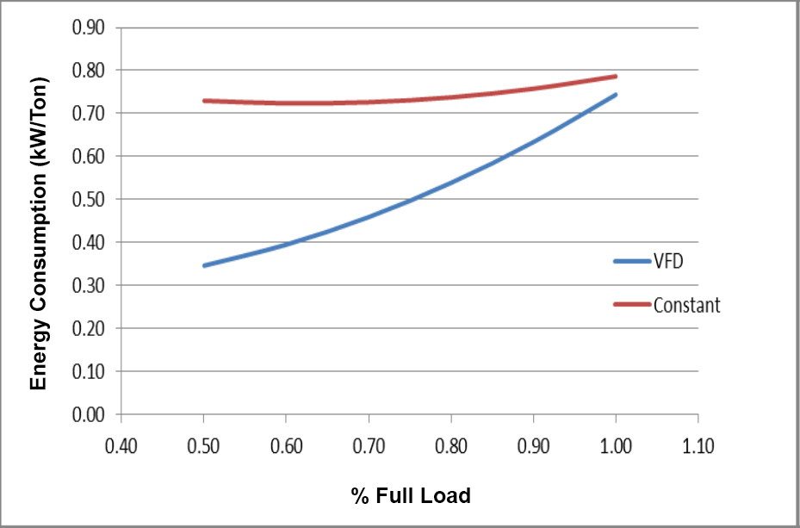

Figure 2: General system differences in efficiency between a constant

speed chiller compared with that of a VFD operated chiller.

Condenser water control also impacts Chiller efficiency. The condenser water temperature control is now set to a minimum of 65°F, at 7° wet bulb.

All three of the chillers were designed to operate at constant speed and relied on inlet guide vanes to modulate the capacity of the chillers. The vanes improved the partial loading efficiency of chillers. The COP installed variable frequency drives (VFDs) on two of the three chillers. The third chiller was kept for peak demand operation.

Below is a screen shot image of the system PC chiller control and monitoring. The second image (below right) is the HMI of the chiller optimization packages’ controller.

 

The condenser water reset temperature control, further reduces the lift of the chiller thereby favorably impacting chiller operation and efficiency.

Audit Overview

An independent energy management firm inspected the facility and used an eQuest (version 3-64) simulation model to collect data. This study was completed by the St. Louis based utility.

The simulation was first built using as-built parameters which included two of the three chillers being equipped with VFDs and condenser water reset controls. The model was then calibrated using billing data and 2014 weather data for the St. Louis area.

Actual chiller operation information was taken from the facility’s energy management system. The data included; chiller tonnage, kW demand, and condenser/chilled water temperatures.

Using the provided data in conjunction with corresponding local weather averages, a regression was developed allowing for the determination of chiller runtime hours.

* The two COP retrofitted chillers should operate approximately 5,815 and 1,725 hours per year.
* The model resulted in annual runtime hours of 5,695 and 1,721 hours.
* The model was very close to the actual run time.

The below model was created by removing the condenser water reset control and removing the VFDs from the two chillers. The annual savings is the difference between the annual consumption of the baseline and as-built model, which can be seen in the following table:

|  |  |  |  |
| --- | --- | --- | --- |
| **End Use** | **Baseline** | **As-Built** | **Savings** |
| Lighting | 3,053,558 | 3,053,558 | 0 |
| Misc. Equipment | 1,215,219 | 1,215,219 | 0 |
| Heating | 1,668,291 | 1,668,291 | 0 |
| Cooling | 1,427,011 | 790,528 | 636,483 |
| Heat Rejection | 50,146 | 53,537 | -3,391 |
| Pumps | 315,374 | 315,374 | 0 |
| Fans | 149,416 | 149,416 | 0 |
| DHW | 152,328 | 152,328 | 0 |
| Exterior | 15,946 | 15,946 | 0 |
| Total | 8,047,285 | 7,414,193 | 633,092 |

Annual kWh Energy Savings

Results

|  |  |  |  |  |
| --- | --- | --- | --- | --- |
| **Measure Category** | **Gross kWh Savings** | | | **Gross Ex Post Peak kW Reduction** |
| **Ex Ante** | **Ex Post** | **Realization Rate** |
| Chiller VFDs | 463,805 | 633,092 | 136% | 120.85 |
| Total | 463,805 | 633,092 | 136% | 120.85 |

Verified Gross Savings/Realization Rates

The model defined the outside air temperature (OAT) and compared the constant speed (CS) with variable frequency drive (VFD) operations. The measured results of the calibration effort are shown below in the chart below.

|  |  |  |  |
| --- | --- | --- | --- |
| **OAT** | **70** | **80** | **90** |
| **CS** | **96.31** | **112.13** | **127.96** |
| **VFD** | **75.20** | **79.67** | **84.15** |
|  | **-21.9%** | **-28.9%** | **-34.2%** |

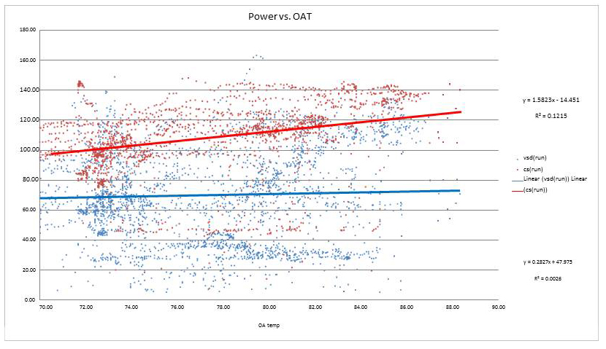

Conclusion

As the study indicates, a much more efficient way to adjust to changing load characteristics or lower condenser water temperatures is to vary the speed of the chiller’s impeller. The COPretrofit accomplishes this by controlling the voltage and frequency of the electrical power consumed by the compressor motor. The magnum continually optimizes chiller speed in order to realize the energy savings.

In closing, Air Masters and Yaskawa America have a standard product that can reduce your chiller power demand by about 30% annually. Given the many mechanical and control benefits, the COP is a very reasonable solution to DRIVE your energy costs down!