Variable Frequency Drive (VFD)

HV600 Bypass Mechanical Specification Submittal
For Narrow Bypass UL Type 12 Rated (H6BN) Packages

GENERAL
The HV600 is a high performance PWM (pulse-width-modulated) AC drive. Three-phase input line power is converted to a sine-coded, variable frequency output, which provides optimum speed control of any conventional squirrel cage induction motor. The use of IGBTs (Insulated Gate Bipolar Transistors), with a carrier frequency range of 2 kHz to 12.5 kHz, permits quiet motor operation.
This drive has one control logic board for all horsepower ratings. Printed circuit boards employ surface-mount technology, providing both high reliability, and small physical size of the printed circuit assemblies. The microprocessor delivers the computing power necessary for complete three-phase motor control in building automation systems.
Operating Principle: Input three-phase AC line voltage is first rectified to a fixed DC voltage. Using pulse width modulation (PWM) inverter technology, the DC voltage is processed, to produce an output waveform in a series of variable-width pulses. Unique firmware algorithms optimize motor magnetization through control of voltage, current, and frequency applied to generate a nearly sinusoidal output waveform.

STANDARDS
UL 508A (Industrial Control Panels)
BTL Listed
UL, cUL listed

ENVIRONMENTAL & SERVICE CONDITIONS
Ambient service temperature: Narrow Bypass UL Type 12: -10°C to 40°C
Ambient storage temperature: Narrow Bypass UL Type 12: -20°C to 70°C
Humidity: 0% to 95%, non-condensing
Altitude: to 1,000 meters (3,300 feet); higher by derating
Service factor: 1.0
RoHS 2 Compliant

QUALITY ASSURANCE
In-circuit testing of all printed circuit boards is conducted to ensure proper manufacturing.
Final printed circuit board assemblies are functionally tested via computerized test equipment.
All fully assembled controls are computer tested with induction motor loads to assure unit specifications are met.
The average MTBF (Mean Time Between Failure) is 28 years.

CONSTRUCTION
Input Section of the VFD - VFD power input stage converts three-phase AC line power into a fixed DC voltage via a solid-state, full-wave diode rectifier with MOV (Metal Oxide Varistor) surge protection. An internal 5% split choke built in both positive and negative DC bus reduces harmonics for cleaner power.
Intermediate Section of the VFD - DC bus maintains a fixed DC voltage with filtering and short circuit protection as a DC supply to the VFD output section. It is interfaced with the VFD diagnostic logic circuit to continuously monitor and protect the power components.
Output Section of the VFD - Insulated Gate Bipolar Transistors (IGBTs) convert DC bus voltage to a variable frequency and voltage, utilizing a PWM sine-coded output to the motor. Motor noise at 60 Hz is less than 2 dB above the motor noise from across-the-line operation when measured at a distance of one meter.

POWER AND CONTROL ELECTRONIC HOUSINGS
UL Type 12 wall-mounted enclosure: 208 V, 0.5 through 20 HP; 480 V, 0.75 through 40 HP
Microprocessor-based control circuit
Non-volatile memory (EEPROM); all programming memory is saved when the VFD is disconnected from power.
Digital operator keypad and display provide local control and readout capability:
Hand/Off/Auto commands
Speed Reference command
Reset command
Easy to remove heat sink cooling fan with programmable on/off control.
USB mini-B port for quick and easy PC connection

PROTECTION
Output current overload rating of 110% for 60 seconds, 140% for 2 seconds, 175% instantaneous
Output short circuit protection
Current limited stall prevention (overload trip prevention) during acceleration, deceleration, and run conditions
Optically isolated operator controls
Fault display
“Hunting” prevention logic
Electronic ground fault protection
Electronic motor overload relay protects the motor while operating in drive and bypass mode
Motor current display in both drive and bypass modes of operation as well as verification that the motor is running
Proof of flow/loss of flow detection in both drive and bypass modes
DC bus charge indication
Heatsink overtemperature protection
Cooling fan operating hours recorded
Input/output phase loss protection
Line voltage sensors to monitor for brownout and blackout conditions with adjustable fault levels to ensure the proper settings pursuant to each application.
Reverse prohibit selectability
Short circuit withstand rating of 100 KA RMS with customer provided branch circuit protection.
Multiple emergency override modes (across-the-line or speed selectable via the drive)

OPERATION
Output frequency and speed display can be programmed for other speed-related and control indications, including: RPM, CFM, GPM, PSI, in WC, % of maximum RPM, or custom.
Power loss ride-through (2 seconds capable)
Time delay on start; peak avoidance for smooth generator switchover
VFD accepts either a direct acting or a reverse acting speed command signal.
Bi-directional “Speed Search” capability to start into a rotating load. Two types: current detection and residual voltage detection
DC injection braking, to prevent fan “windmilling”
Remote Run/Stop command input
Eight programmable HVAC specific application presets
Over 100 programmable functions, resettable to factory HVAC presets
User parameter initialization to re-establish project specific parameters
Ramp-to-stop or coast-to-stop selection
Auto restart capability: 0 to 10 attempts with adjustable delay time between attempts
One custom selectable Volts/Hertz pattern and multiple preset Volts/Hertz patterns
Auto speed reference input signal, adjustable for bias and gain
While the VFD is running, operational changes in control and display functions are possible, including:
Acceleration time (0 to 6000 seconds)
Deceleration time (0 to 6000 seconds)
Frequency reference command
Hand/Off/Auto commands
Monitor display
Removable digital operator
Automatic energy saving, reduced voltage operation in VFD mode

PRODUCT FEATURES
Displacement power factor of .98 throughout the motor speed range
Internal EMI/RFI filter complies with IEC 61800-3 restricted distribution for first environment
Built-In real time clock for time and date stamping events along with timer functions for starting, stopping and speed changes without the need for external controls
Voltmeter, ammeter, kilowatt meter, elapsed run time meter, and heatsink temperature monitoring functions
Drive internal PI closed-loop control with selectable engineering units
Independent PI control for use with external device
Differential PID feedback feature
Direct or reverse acting speed signal
Sleep function in both closed loop and open loop control
Feedback signal low pass filter
Feedback signal loss detection and selectable response strategy
Feedback signal inverse and square root capability
24 VDC, 150 mA transmitter power supply
Eight programmable multi-function input terminals (24 VDC) providing 36+ programmable features, including:
Customer Safeties
BAS / Damper Interlock
Emergency Override – BAS interlock mode
min/max speed setting
16 preset speeds
PI control enable / disable
Two programmable 0 to 10 VDC or 4-20 ma analog outputs on VFD control board, proportional to drive monitor functions including output frequency, output current, output power, PI feedback, output voltage and others
Four programmable multi-function output relays (Form C rated 2 amps @ 250 VAC & 30 VDC) providing 29+ functions, including: “Motor Run,” “Damper Control,” “Auto Transfer,” “Drive Run,” “Hand Mode,” “Auto Mode,” “System Fault,” “Bypass Run,” ”Serial Com Run,” “Ready/Run/Fault status,” and numerous other options.
Input and output terminal status indication
Analog input speed reference on bypass printed circuit board
Nine preset speeds
Diagnostic fault indication
VFD efficiency: 96% at half-speed; 98% at full-speed
“S-curve” soft start / soft stop capability
Run/Fault output contacts
Serial communication loss detection and selectable response strategy
Controlled speed range of 40:1
Critical frequency rejection capability: three selectable, adjustable bandwidths
140% starting torque capability, available from 3 Hz to 60 Hz
Adjustable carrier frequency, from 2 kHz to 12.5 kHz
Analog/Digital Virtual I/O – internally sends an output to an input (no wiring needed)
Dynamic noise control for quiet motor operation
Programmable security code
Cloud service (Yaskawa Drive Cloud) for product registration and parameter storage
Store up to four additional parameter sets in keypad
Integrated PLC (DriveWorks EZ)
Rotational as well as Stationary motor auto-tuning
Temperature controlled fans
LCD keypad with Hand/Off/Auto and Copy keypad functions
Motor preheat function
Self-regulating lead/lag control for multiple drives (up to 4)
Drive/motor alternation control (share motor run time for lead drive/motor)
Up to four PID setpoints
Draw down level selection for PID setpoint
Anti-no-flow control for deadhead protection
Pre-charge pump functionality
Low city alarm digital input
State/de-state control – add/remove drive based on feedback or output frequency
Single phase foldback
Flash upgradeable firmware
Heatsink overtemperature speed fold-back feature
“Bumpless” transfer between Hand and Auto modes
Emergency override can be used as “smoke purge” function
Fan failure detection and selectable drive action
Programming and firmware upgrade without three-phase main power using DriveWizard HVAC software tool
Bypass and drive are factory assembled.
Input disconnect switch with a lockable, through-the-door operating mechanism
Drive output and Bypass contactors are both electrically and software interlocked.
BACnet, Siemens APOGEE FLN, Metasys N2, and Modbus RTU communication protocols as standard, with the ability to configure controller parameters, view controller monitors, control I/O, clear faults, and view controller status in both drive and bypass modes. EtherNet/IP, Modbus TCP/IP and LonWorks are optionally available.
BACnet Health monitors including Net Health, Tokens Received/Transmitted, Messages Received/Transmitted, Next/Previous Node Address, Max/Min Master Found, number of Nodes on Network, COV, MSTP Loop Time, CRC Errors, MSTP Tokens Lost/Retry, Deadtime Average.
Door mounted control keypad with HOA LCD display for “Control Power,” “Drive Ready,” “Drive Run,” “Drive Selected,” “Drive Fault,” “Drive Test,” “Bypass Selected,” “Bypass Run,” “Motor OL”, ”Safety Open” “BAS Interlock,” “Auto Run”, Auto Transfer,” “Emergency Override,” “Hand Mode,” “Off Mode”, and “Auto Mode.”
Damper control circuit with end-of-travel feedback capability including two adjustable wait time functions. One is a run delay time, where the drive will operate at a preset speed before the damper opens to pressurize the system. The other time function is an interlock wait time, so if the damper has not fully opened within the specified time, a fault will be declared.
Selectable energy savings and harmonic reduction mode. Drive automatically switches to Bypass (across-the-line) when motor is running 60 Hz for a set time and automatically switches back when frequency reference changes.
Green Contactor mode when enabled will keep unneeded contactors from being closed when not needed.

Model Number Configuration (H6BN)

Step 1. Complete the Base Number for the voltage and current rating.

Step 2. Add the Option Code letter for each required option. If an option is not wanted, no character is inserted in that position.
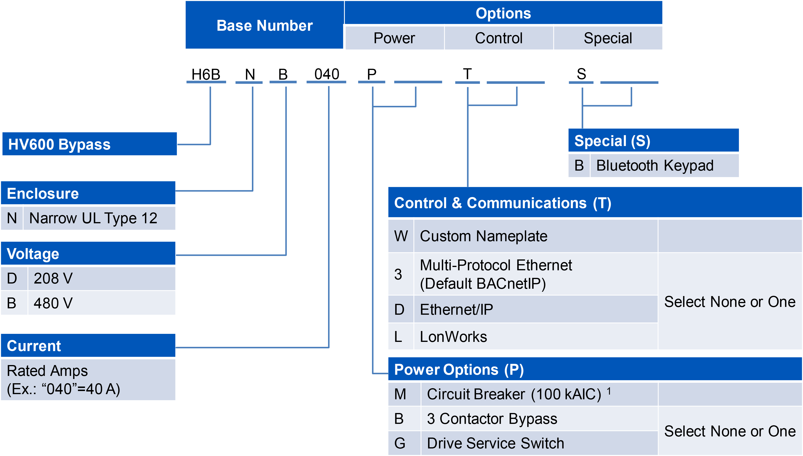

ENCLOSURE TYPE
[P] Narrow Bypass UL Type 12 Package

VOLTAGE
[D] 208 volt model for nominal, 200 or 208 VAC (+10/-15%); 60 or 50 Hz (+/-5%) systems
[B] 480 volt model for nominal, 380, 400, 415, 440, 460 or 480 VAC (+10/-15 %); 60 or 50 Hz (+/-5%) systems

[P] POWER OPTIONS
MAIN INPUT DISCONNECT (Default)
Input disconnect switch with a lockable, through-the-door operating mechanism, no branch short circuit protection.
[M] Circuit Breaker Option is a 100 kAIC rated circuit breaker with fuses. When option (M) is specified, the configured drive package will be rated at 100 kAIC.
(Replaces default input disconnect)
[P] POWER OPTIONS (Continued)
One or None:
[B] Three-Contactor Bypass, (Replaces Standard Two-Contactor Bypass)
[G] Drive Input Service Switch

[T] CONTROL & COMMUNICATION OPTIONS
[W] Engraved nameplate
None or One:
[3] Multi-Protocol Ethernet (Default BACnetIP)
[D] Ethernet/IP
[L] LonWorks

[S] Special
[B] Bluetooth Keypad

