TABLE OF CONTENTS
1. About This Document 2
2. Requirements 2
3. Instructions to add Sigma-5-SD component to SigmaWin+ 3
4. Instructions to download a motor file to a Sigma-5-SD SERVOPACK 4
Appendix A: Sigma-5-SD Component Detailed Installation 10

About This Document
This document is intended for end users of Sigma-5-SD Series products. It describes how to add the Sigma-5-SD component to SigmaWin+ Ver. 5.75 or above, and how to download a motor file to the SERVOPACK.

Requirements
- SigmaWin+ Ver. 5.75 or above must be installed.
- Sigma-5-SD Component installer downloaded from Yaskawa website.
- Motor File downloaded from Yaskawa website and matches part number of motor to be used.
- Contact Yaskawa if trying to connect to an EtherCAT SERVOPACK.

Instructions to add Sigma-5-SD component to SigmaWin+
- Verify requirements on section 2 are met.
- Run the Sigma-5-SD component installer. The installer’s name is SWFVSD100_SetupE.exe.
- After successfully installing this component, it will appear next time SigmaWin+ is executed.
- Execute SigmaWin+ and verify Sigma-5-SD module can be seen as in the following:

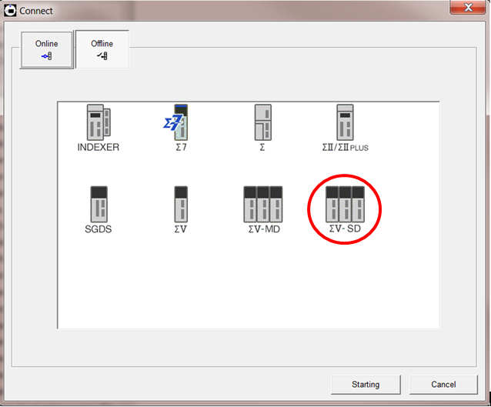
Figure 1 - Sigma-5-sd module added to sigmawin+
- If the Sigma-5-SD module was installed correctly as in Figure 1, then SigmaWin+ is ready to be connected to any Sigma-5-SD SERVOPACK.
- If the Sigma-5-SD module cannot be seen as in the figure above, try installing the component again following instructions on Appendix A.

Instructions to download a motor file to a Sigma-5-SD SERVOPACK
- Make sure only control power (24V) is being supplied to the converter and inverter.
- Using Yaskawa USB cable, connect the SERVOPACK to SigmaWin+ Ver. 5.75 or above.
- Once connected, select Setup(S) from the menu bar and click on “Motor parameter servopack write(W)”
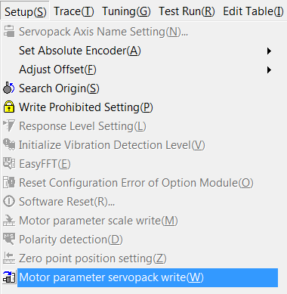
- Select “OK” on the next screen to start reading information from the SERVOPACK
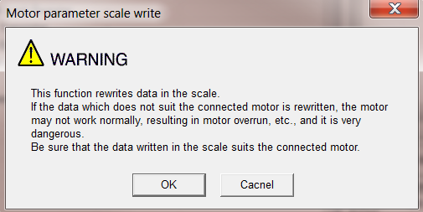

- In the Motor parameter servopack write – File Select window, select Ref.
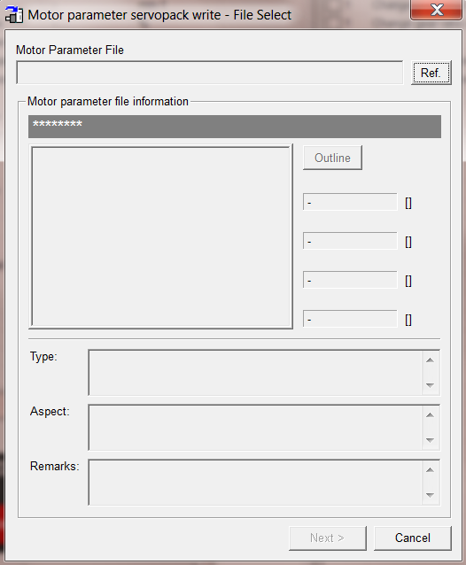

- Select the motor file to be downloaded to the SERVOPACK and click on Open.
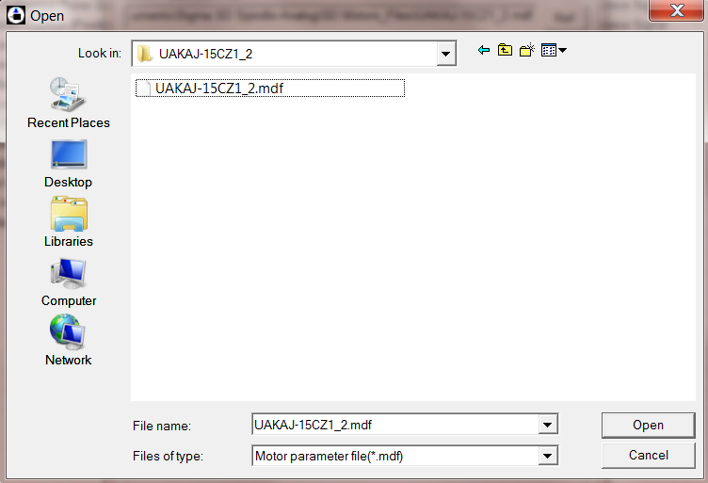
- Make sure the motor file matches the motor installed, and then click on next.
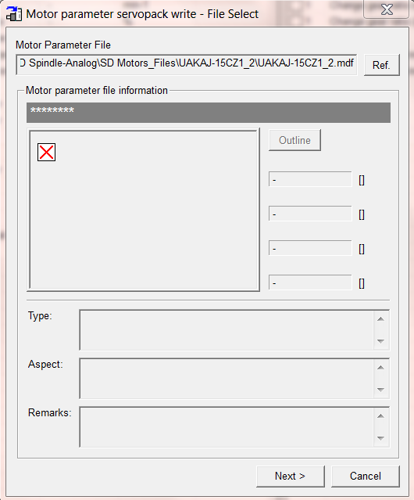

- Click on write to download the motor file to the SERVOPACK.
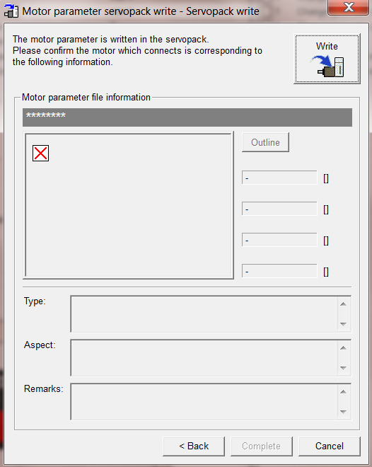
- Click on Yes on the warning message, and the motor file would be downloaded to the SERVOPACK.
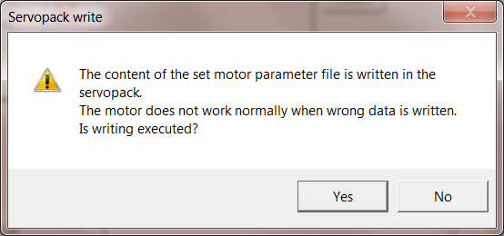

- Click on Complete on the next screen to confirm the completion of the procedure.
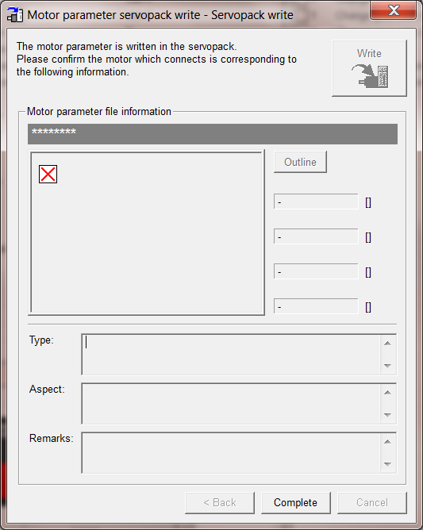
- Click on OK on the CAUTION message.
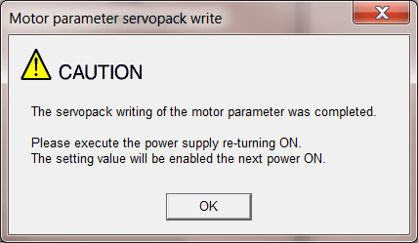
- Turn off and on the control power (24V) being supplied and the download procedure is now complete.

- To verify that the motor file has been downloaded successfully, open SigmaWin+.
- SigmaWin+ would normally be connected to the Sigma-5-SD SERVOPACK at this point, if not reconnect to the drive.
- Go to Monitor(M), then Product Information(P)
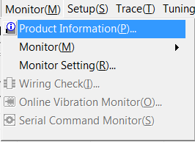
- In the following popup screen, verify that motor type matches the part number of the installed motor.
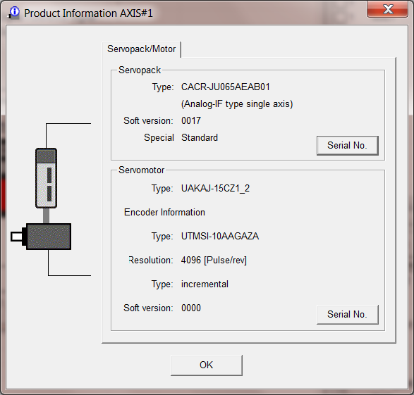
- If the motor type matches, then the download procedure has been done successfully; otherwise, the motor file downloaded to the drive is for a different spindle motor than the one installed. If that is the case, then download the right motor file and follow this procedure again.
- Sigma-5-SD Component Detailed Installation

- Make sure Sigma-5-SD installer’s name is SWFVSD100_SetupE.exe.
- Run SWFVSD100_SetupE.exe.\
- Click on Next on the following installation screen:
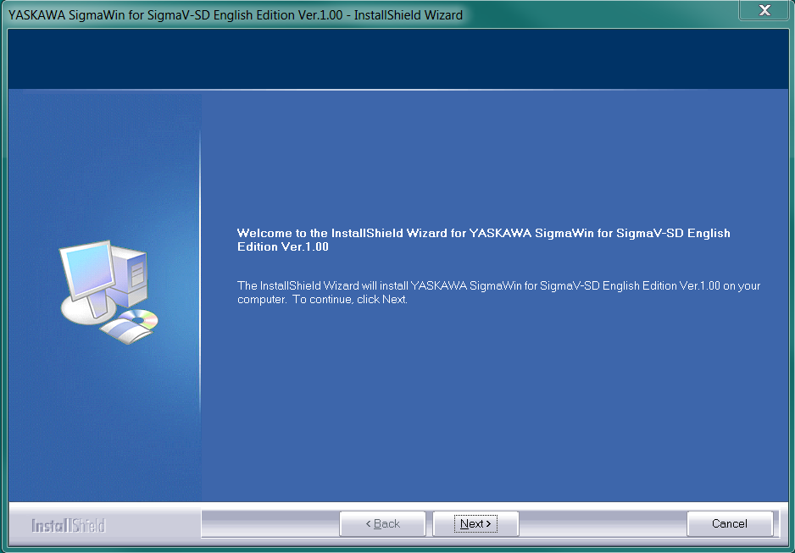

- Accept the terms of the license agreement and click on Next.
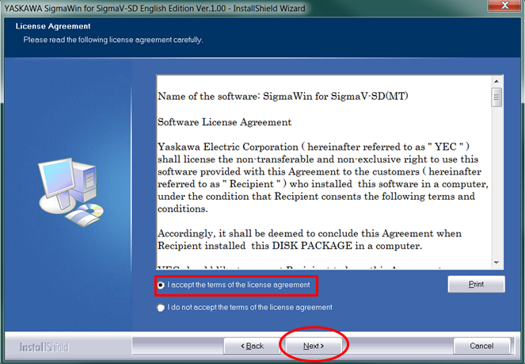
- Click on Install and wait a few seconds for the installation to be completed.
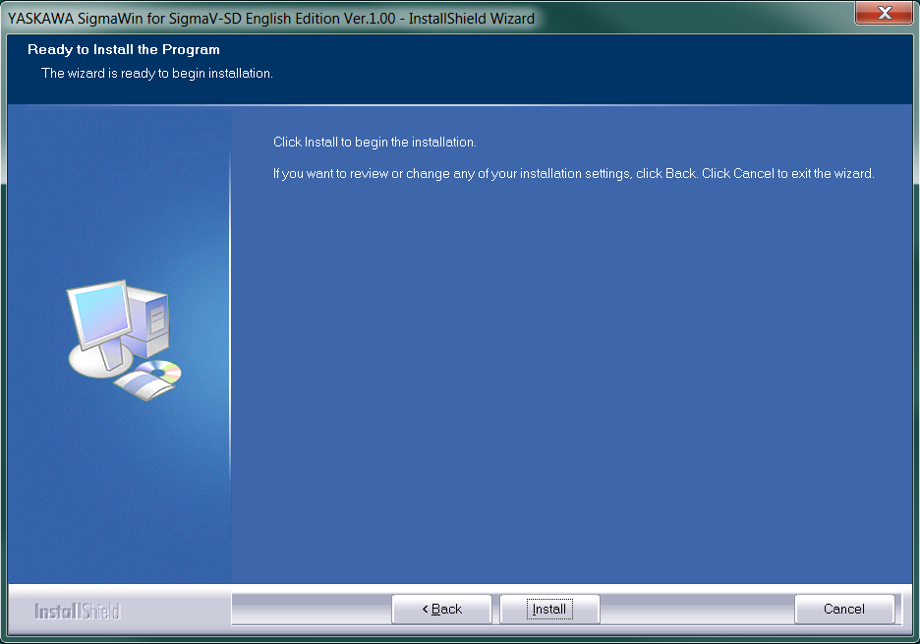

- Click on Finish to finalize the installation
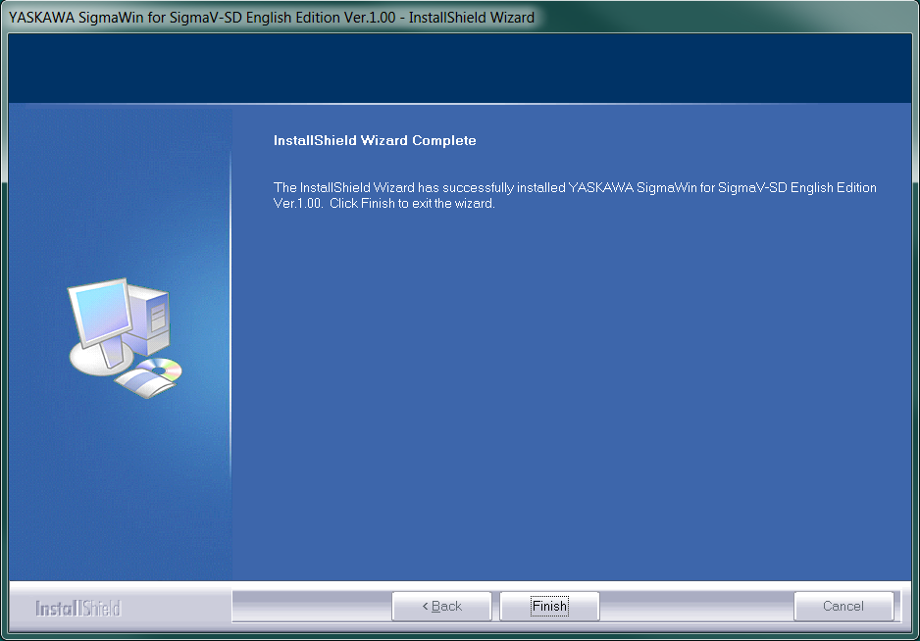

- After successfully installing this component, it will appear next time SigmaWin+ is executed.

