What is the Sigma-7 Shielding Clamp?
The Yaskawa Sigma-7 Shielding Clamp is a cable shielding clamp designed to be used in conjunction with Yaskawa’s 400V Servo Systems.
The clamp completes the connection between the motor power cable’s shielding and the grounded amplifier base.
The clamps are available for order in 3 different sizes, covering various thicknesses of Yaskawa Power cables for use with Yaskawa motors:
Order Number | 400V Motor Size
KLBUE4-13.5_SC | Up to 3.0 kW
KLBUE10-20_SC | 5 kW to 7.5 kW
KLBUE15-32_SC | 11 kW to 15 kW

Why use the Sigma-7 Shielding Clamp?
- Help remove electrical noise from your electromechanical system - This can help to aid in system response and reduce the potential for motion errors
- Installs in minutes – saves the hassle of creating custom cable routing fixtures that typically have time consuming installation requirements
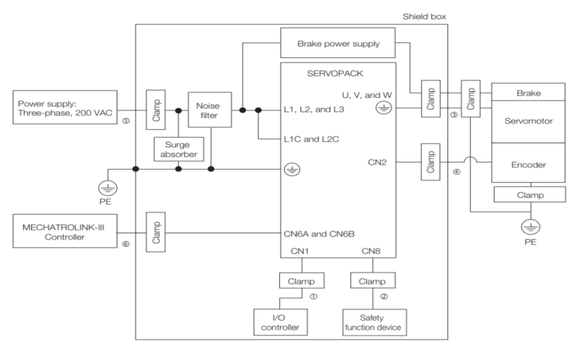
- Helps bring Yaskawa systems into EMC compliance – this portion of the system is highlighted in the EMC compliance diagram located below

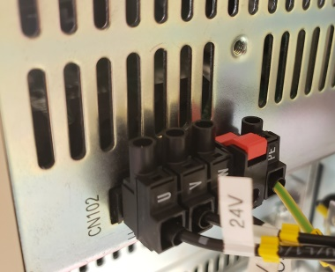
Installation Guide
Step 1 – Locate the installation hole on the bottom of the amplifier. The installation hole will be a small tapped hole located near the UVW power connector of the amplifier.
Step 2 – Install the installation clamp into the hole using a hex key (3mm). Tighten the screw until it is firmly tightened, but be careful to not over tighten. It is recommended to face the opening of the clamp away from the UVW power connector, so that the cable may be inserted more easily.

Step 3 – Pull up the spring so that the cable may be inserted into the clamp.

Step 4 – Insert the exposed shielding near the UVW end of the power connector into the cable clamp, and release the spring so that the clamp grips the cable.
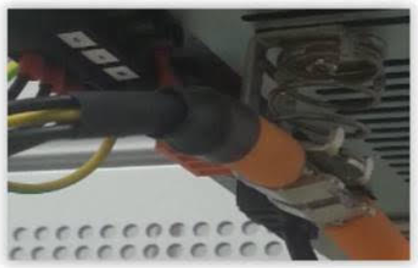

Once completed, the cable clamp assembly will look like this on the amplifier:

