MC_TouchProbe requires a TRIGGER_REF structure to be connected to the block to configure the physical input used and other details.
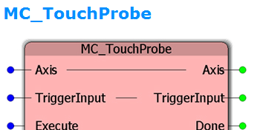
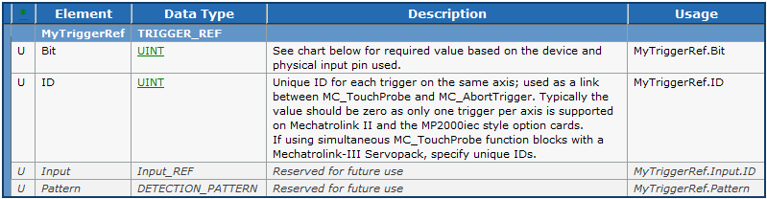
Prior to firmware 2.5, the TRIGGER_REF.ID element was not used by the MP2000iec controllers and any value would be accepted. In 2.5, the TRIGGER_REF.ID field must be a zero for MP2000iec series controllers. In older help documentation, an example showed the ID set to 1, and many users set TRIGGER_REF.ID to 1 in their projects, which causes MC_TouchProbe to output ErrorID 4630 when using firmware 2.5 or higher. The solution is to set MyTriggerRef.ID to zero which will work for all firmware versions. Only on the MP3000iec controllers, with Mechatrolink-3 SGDV Servopacks, can another value be used for the case of availability multiple latches configured on the same axis.

